META PLATFORMS: A POWERHOUSE INVESTMENT OPPORTUNITY



Meta Platforms, the company behind Facebook, Instagram, WhatsApp, and Messenger, has come a long way since its early days. With a market cap sitting around $1.3 trillion, Meta is a giant not only in social media but in the broader tech landscape. Beyond its massive user base, the company has been making strategic moves in new areas like artificial intelligence, virtual reality, and augmented reality, all while continuing to deliver impressive financial results. Let's break down why Meta remains one of the most exciting investment opportunities out there, from its strong financials to its position against competitors, and yes, its forays into AI!

A DOMINANT FORCE IN THE DIGITAL WORLD

At its core, Meta Platforms thrives as a social technology company. More than 3.2 billion people interact with at least one of its apps daily—an absolutely staggering reach. From Facebook and Instagram to WhatsApp and Messenger, Meta connects billions of people around the globe, giving the company an unrivaled amount of data and engagement.

What’s driving Meta’s success right now? Digital advertising. Meta generates nearly all of its revenue from advertisements on its platforms. In Q2 2024 alone, the company posted $39.1 billion in revenue, with the majority coming from its highly targeted ad system. Thanks to advanced data analytics, Meta is able to serve precise, effective ads to its massive user base, creating value not just for users, but also for businesses looking to reach their target audiences.

Note that while social media usage trends can shift, the world’s increasing reliance on digital platforms provides Meta with almost limitless digital real estate to monetize. As long as people keep scrolling, the company will keep capitalizing on it. Plus, the global digital ad market is projected to grow at a compound annual growth rate of 15.5% through the end of this decade, giving Meta a massive opportunity to increase its revenue even further.

FINANCIAL POWERHOUSE

Let’s talk numbers, because this is where Meta really shines as an investment. Meta's Q2 2024 financial performance was nothing short of impressive. The company posted a jaw-dropping 22% year-over-year revenue growth and a 60% rise in profit, beating analyst expectations. Meta’s overall gross profit margin came in at 81%, which is particularly strong for a company investing heavily in emerging technologies like VR, AR, and AI.

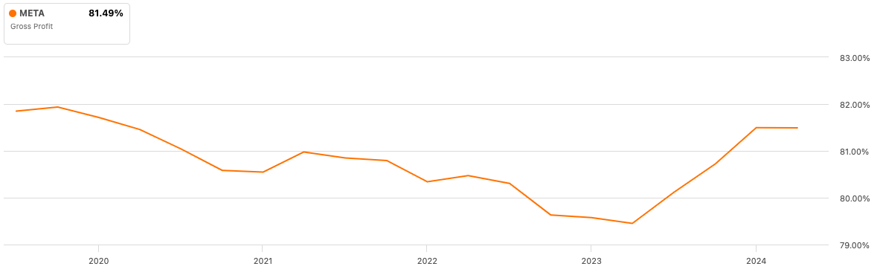

Another key figure? Free cash flow. Meta generated $23.4 billion in free cash flow during the first half of 2024 alone. For investors, this is huge because it gives Meta the flexibility to reinvest in its business—whether that’s stock buybacks, dividends, or new innovations. In fact, Meta’s strong cash flow has allowed it to buy back billions of dollars in shares, boosting shareholder value even further. This makes Meta not just a growth stock, but a balanced one, offering both capital appreciation and cash returns.

Earnings per share (EPS) are expected to grow at a compound annual growth rate of 23% from 2024 to 2026. In 2024, EPS estimates are set at $21.29, marking a 37% year-over-year growth. And in 2025, EPS is projected to increase another 14%, reaching $24.20. For a company that’s already operating at the top of its game, these numbers suggest Meta still has a lot of room to grow!

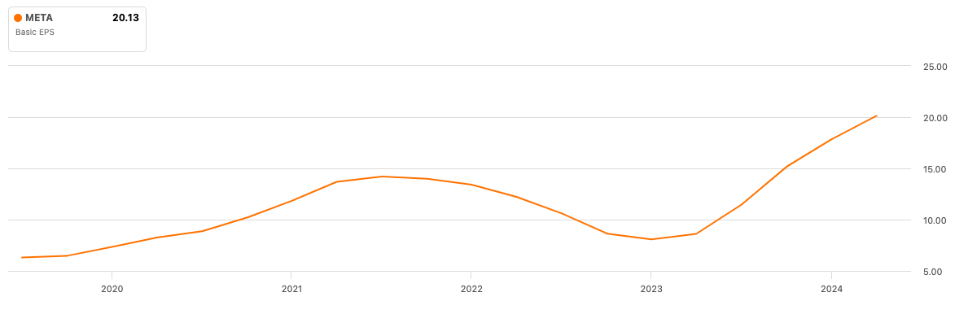

COMPETITIVE LANDSCAPE – META VS. THE OTHER MAGNIFICENT SEVEN



When you’re a giant like Meta, there’s always competition lurking around the corner. In the tech world, the competition comes in the form of the “Magnificent Seven”—the group of the largest U.S. tech companies that includes Alphabet (Google), Amazon, Apple, Microsoft, Nvidia, Tesla, and of course, Meta. But let’s be real—Meta’s position in this group is unique.

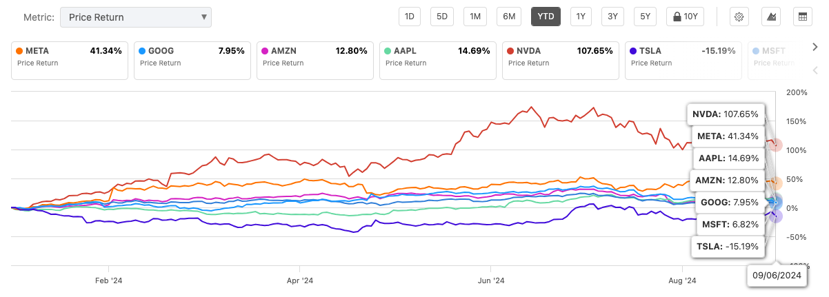

Unlike its competitors, Meta isn’t overly reliant on hardware sales or cloud services. Instead, its strength lies in its massive social platforms and highly efficient ad business. Alphabet (Google), its main rival in digital advertising, has a much more diversified revenue stream, but Meta has been outperforming Google on several fronts. Meta’s ability to grow faster than its peers, despite already being a mature business, makes it a standout among the tech elite.

What about the other players? Amazon and Microsoft are more focused on e-commerce and cloud computing, while Nvidia’s skyrocketing stock price has been driven by its dominance in AI chips. Tesla and Apple, meanwhile, dominate their respective fields, but of course, neither can match Meta’s dominance in the digital ad space or social media engagement.

The bottom line? Meta doesn’t have to worry too much about competition in its core business. Sure, Google is close behind, and other tech giants like Microsoft and Apple continue to innovate, but none have the social media grip that Meta enjoys. That’s a competitive moat few companies can boast.

BETTING BIG ON METAVERSE AND VR



Mark Zuckerberg has made it crystal clear that the metaverse is Meta’s long-term play. While this vision of the future—a mix of virtual and augmented realities—has yet to fully materialize, Meta is investing billions into making it a reality. Through Reality Labs, Meta’s VR and AR division, the company has already launched products like Meta Quest (its VR headset), which immerses users in fully interactive digital worlds.

However, Reality Labs is far from profitable at this point. In Q2 2024, Reality Labs posted a $4.5 billion operating loss, but Meta is playing the long game here. They see these early investments as laying the groundwork for future profitability. It’s a risky move, but Meta is one of the few companies with the financial firepower to pull it off. The company’s overall strength allows it to absorb these short-term losses while continuing to innovate and position itself as a leader in VR and AR.

For investors, the metaverse represents a massive, untapped market. If Meta’s vision pays off, it could unlock new revenue streams that dwarf even its current advertising business!

AI IS NOT JUST HYPE

Now, we can’t talk about Meta without mentioning artificial intelligence. Meta has been quietly building up its AI capabilities for years, and now those efforts are starting to pay off. In fact, CEO Mark Zuckerberg has boldly stated that Meta AI could become the most widely used AI assistant in the world by the end of 2024. Meta’s AI isn’t just for chatbots or flashy features. It’s integrated into nearly every aspect of the company’s operations, from enhancing user experiences on Facebook and Instagram to refining ad targeting with machine learning. Meta has even released open-source AI models like LLaMA (currently in its 3.1 version), making it a key player in the broader AI research community.

The company is already developing LLaMA 4, which promises to be a game-changer in generative AI. More importantly, Meta is using AI to improve its ad offerings. In the near future, advertisers won’t need to set up complex campaigns. They’ll simply input their business goals and budgets, and Meta’s AI will handle the rest. This kind of automation will make Meta’s ad business even more efficient and lucrative. While companies like Google and Microsoft also have significant AI initiatives, Meta’s focus on integrating AI into its social platforms and advertising tools gives it a distinct edge. And with more companies turning to AI-driven solutions, Meta’s investments in this area are likely to pay off in a big way.

GROWTH POTENTIAL AND VALUATION

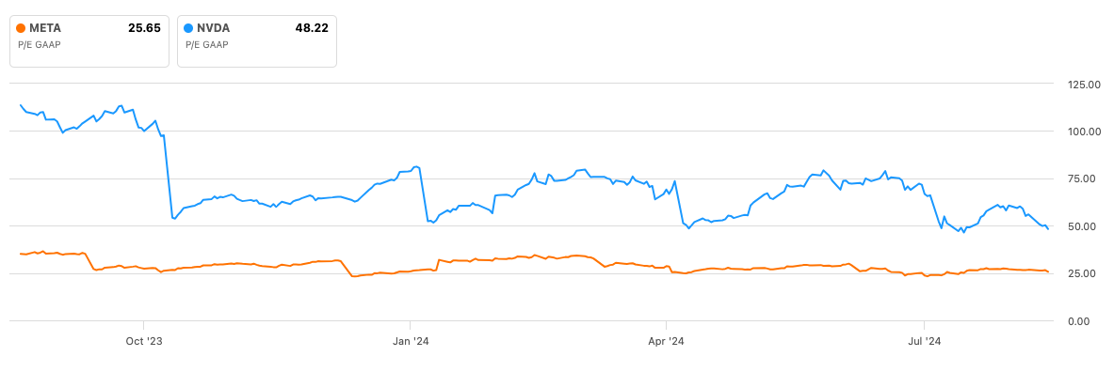

For investors looking for growth at a reasonable price, Meta presents a compelling opportunity. Trading at roughly 25 times forward earnings, Meta is more attractively valued than many of its tech peers. Compare that to Nvidia for example, which trades at 50 times forward earnings, it’s clear that Meta offers a less risky bet, especially given its projected EPS growth.

So Meta’s strong financials, market leadership, and innovative edge make it an interesting opportunity, even as it nears all-time highs. With a combination of robust revenue growth, a strong operating margin, and continued innovation, Meta is well-positioned to deliver solid returns for years to come! Its investments in AI and the metaverse are long-term bets, but Meta’s core business—social media and digital advertising—continues to generate massive cash flow. For investors seeking both growth and value, Meta is a no-brainer!

CONCLUSION – META’S MULTI-FACETED STRENGHTS

Meta Platforms isn’t just a social media company. It’s a tech powerhouse with fingers in many pies, from AI to the metaverse, all backed by a strong financial foundation. While competitors like Google, Microsoft, and Nvidia are fierce, Meta’s unique blend of social platforms, advertising strength, and innovation in emerging technologies makes it a standout in the tech space.

For investors, the combination of a dominant core business, strategic growth initiatives, and attractive valuation metrics positions Meta as a top opportunity. Whether you’re looking for growth, stability, or exposure to cutting-edge tech trends, Meta offers it all. It’s not just about where Meta is today—it’s about where it’s going! And right now, that future looks bright.

