DEEP DIVE ANALYSIS #10
NETFLIX: A STREAMING GIANT THAT KEEPS EVOLVING



Netflix has been a game-changer in the entertainment world for years now, but it’s not just about binge-worthy series anymore. This company has grown into something much bigger, with a business model that’s set to keep evolving. From its early days of mailing DVDs to its global streaming empire, Netflix has always found a way to stay ahead of the curve. But as the competition heats up, how is Netflix keeping its edge? And what’s the deal with the rumors about a stock split?

Before we dive into that stock split talk, let’s take a look at what makes Netflix’s business model tick and how the company is setting itself up for future growth—especially with its recent dive into advertising.

NETFLIX’S WINNING FORMULA: MORE THAN JUST STREAMING

At first glance, Netflix’s business model might seem pretty straightforward: offer tons of movies and shows for a flat monthly fee. But there’s a lot going on behind the scenes. Netflix has managed to keep growing year after year by mixing things up in ways that other companies just can’t seem to pull off.

For starters, Netflix is a subscription-based service, which means it brings in a steady flow of cash every single month. And with over 247 million paid subscribers worldwide in 2024, that's a massive amount of money rolling in consistently. But Netflix’s real magic trick is its original content. The company doesn’t just rely on licensing old shows and movies—it’s been spending billions to create exclusive content that you can only find on Netflix. In fact, in 2023, Netflix shelled out $17 billion on producing new content.

And it’s not just about quantity—Netflix is great at creating cultural hits. Think Stranger Things, The Crown, or Squid Game. These shows aren’t just popular—they become events. This ability to make shows that everyone’s talking about is one of Netflix’s biggest strengths. Plus, Netflix has built a business that’s highly scalable. Once they make a show or movie, it’s available to millions of subscribers instantly, with little added cost. That’s a major advantage because it allows Netflix to keep expanding while maintaining a healthy profit margin.

WHAT MAKES NETFLIX STAND OUT

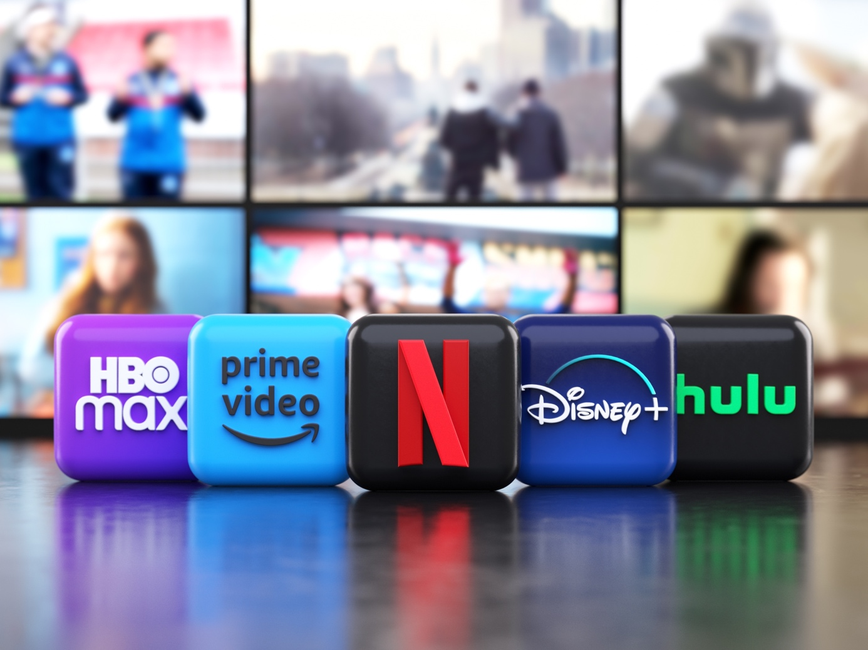

So, what gives Netflix a competitive edge over rivals like Disney+ or HBO Max? First up: global reach. Netflix is available in over 190 countries, which means it has a far larger potential audience than most of its competitors. This global presence allows Netflix to spread the cost of producing content across a huge subscriber base, keeping things efficient and profitable.

Then there’s data. Netflix is a master at using data to figure out exactly what people want to watch. They track viewing habits and use this data to decide what shows and movies to make next. That’s why Netflix keeps rolling out hit after hit—because they know what their audience is craving.

Netflix’s recommendation engine is another key to its success. Every time you log in, Netflix suggests content based on what you’ve watched before. It’s like a personal assistant that knows your tastes better than anyone. This keeps users engaged and, more importantly, subscribed. Another area where it shines is its international content strategy. Netflix isn’t just making shows in English anymore—it’s producing hits in multiple languages. From Spanish-language sensations like Money Heist to Korean dramas like Squid Game, Netflix is tapping into global markets in ways that few companies can. And because these shows are so good, they often break through to audiences outside of their home countries, giving Netflix even more bang for its buck.

ADVERTISING: NETFLIX’S NEW MONEY-MAKER

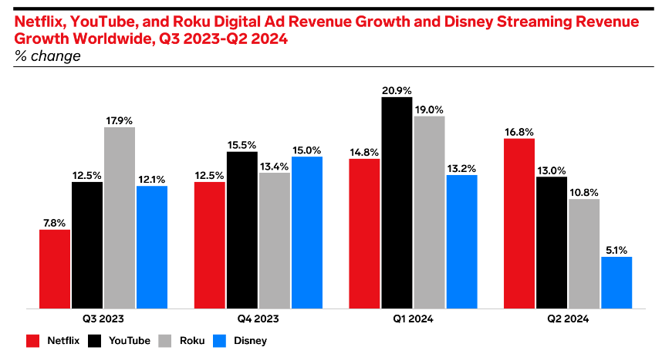
Source: emarketer.com

While Netflix’s subscription model has been wildly successful, the company is always looking for new ways to grow. That’s where advertising comes in. In 2023, Netflix rolled out a new, cheaper ad-supported tier priced at $6.99 per month. This was a big move for a company that had previously stayed far away from ads.

Why the shift? It’s all about reaching more people. By offering a lower-priced option, Netflix can attract price-sensitive customers who may have hesitated to sign up before. But there’s more to it than just bringing in new subscribers—advertising opens up a whole new revenue stream for Netflix. The global digital ad market is huge, and Netflix is now positioning itself to get a slice of that pie. Industry insiders estimate that Netflix’s ad revenue could make up over 10% of its total revenue by 2027, and it could keep growing from there. With such a massive and engaged audience, advertisers are willing to pay top dollar to get their message in front of Netflix viewers.

Of course, Netflix has to find the right balance here. Too many ads could turn people off, but if Netflix can get it right, this new revenue stream could be a game-changer.

A LOOK AT THE NUMBERS: NETFLIX IS STILL CRUSHING IT

So, how’s Netflix doing financially? In a word: great. Despite increasing competition, Netflix’s numbers remain impressive. In the second quarter of 2024, Netflix reported revenues of $9.55 billion, up from $9.3 billion the year before. A solid achievement considering the company’s massive scale. It’s even more remarkable when you consider Netflix’s operating income, which has also been rising steadily. Netflix’s profitability has seen a big boost, with annual profits jumping from $1.86 billion in 2019 to over $5.4 billion in 2023, highlighting just how efficiently the company is managing its growth.

And it’s not just about the top line. Netflix’s gross margin reached 43.8% in 2024 (see graph below with some competitors, Disney & Spotify), marking a significant recovery from the rough patch it experienced in 2022. Back then, the company faced challenges with slowing subscriber growth and tightening competition. However, thanks to smarter cost management and a renewed focus on growth, Netflix has outpaced many of its rivals in the streaming wars. Its operating income also surged to nearly $7 billion, further showcasing its operational efficiency.

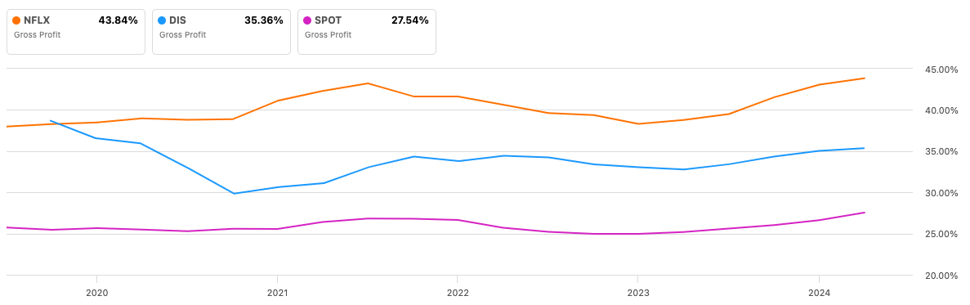

And what’s more, Netflix is crushing it when it comes to Return on Equity (see graph below), especially compared to Disney and Spotify, and it all comes down to how smartly their business is set up. As we said, Netflix keeps costs low by producing a ton of its own content, and since it's a subscription-based model, it can spread those costs over millions of subscribers around the world. Disney, on the other hand, has a lot of moving parts—theme parks, movies, TV networks—which are way more expensive to run, so it doesn’t see the same kind of profitability. Disney+ is still growing, but it’s not bringing in the same returns as Netflix just yet. As for Spotify, their ROE is a bit more limited because they have to pay big royalties to music labels, which cuts into their profits.

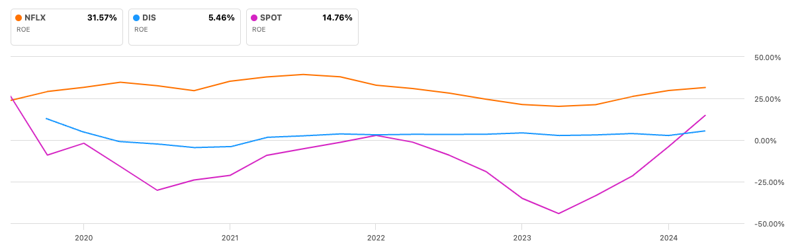

But there’s one metric Netflix needs to keep an eye on: engagement. While Netflix added more than 39 million new subscribers in the past year—driven largely by its crackdown on password sharing and the introduction of its ad-supported tier—the total hours watched have barely budged. In fact, Netflix revealed that its subscribers watched a total of 94 billion hours of content between January and June 2024, only a 1% increase from 2023. Additionally, the average daily hours watched per subscriber dropped from 2.1 to 1.9 hours year over year.

Despite these engagement concerns, Netflix isn’t worried. The company is banking on its strategic moves—like the push for password sharing reforms and the newly introduced ad-supported tier—to spur further growth. And with such a huge subscriber base, even small improvements can lead to big gains. Netflix's ability to boost average revenue per user (ARPU), particularly in key regions like the U.S. and Canada (where ARPU increased from $16 to $17.17), suggests that the company is finding ways to monetize its audience more effectively, even as viewing habits shift.

STOCK SPLIT: WILL NETFLIX MAKE THE MOVE?

Now, let’s talk about the stock split rumors. Netflix’s stock is currently trading at over $700 a share, which is pretty pricey for many investors. A stock split would make shares cheaper and more accessible, especially to smaller, retail investors.

If you’re wondering how this works, a stock split is like slicing a pizza into more pieces. The total value of the company doesn’t change, but the price per share goes down. For example, in a 4-for-1 split, if you own one share worth $400, you’d now have four shares worth $100 each. It’s a common move for companies whose stock price has gotten a bit too high, and it can often drive demand as more people are able to buy in. Netflix hasn’t split its stock since 2015, and with the stock price at such a high, now could be the perfect time. Netflix is also set to announce its next earnings report in October 2024, and that would be a prime moment to reveal a stock split if it’s in the cards.

For investors, a stock split could be a great opportunity. Not only would it make Netflix shares more affordable, but it could also lead to a short-term boost in the stock price as more people jump in.

WHAT’S NEXT FOR NETFLIX?



As Netflix looks to the future, it’s clear that the company is in a strong position. Between its innovative content strategy, its expansion into advertising, and the possibility of a stock split, Netflix has plenty of growth opportunities ahead. Of course, there are challenges too. The streaming space is more crowded than ever, and Netflix will need to keep innovating to stay ahead of its rivals.

But one thing is certain: Netflix isn’t slowing down anytime soon. Whether you’re a current investor, thinking about buying in, or just a fan of their content, there’s no denying that Netflix is a company that knows how to keep things interesting—both on the screen and on the stock market.

