KEY INVESTMENT INSIGHT #7
THE FREE CASH FLOW ANALYSIS



Let’s be real – when it comes to investing, many people get excited by headline-grabbing figures like revenue growth or net income. But if you’re only looking at those numbers, you might miss a crucial part of the picture: free cash flow (FCF). Free cash flow is one of the most insightful metrics you can use to understand how well a company is really performing, especially when you’re looking for long-term value and sustainability. Today, we’re going to break down what free cash flow is, how to calculate it, and why it’s so important for investors like you.

WHAT IS IT EXACTLY?

You’ve probably heard the term before, but what does it really mean? In simple terms, free cash flow represents the cash a company has left after paying for its operating expenses and capital expenditures (such as property, equipment, or inventory). It’s the money the business can use to pay off debt, reinvest, distribute dividends, or keep in reserve for future opportunities.

The beauty of FCF is that it strips out non-cash items like depreciation and amortization, giving a clearer picture of how much actual cash a company is generating. For investors, FCF is a goldmine because it provides insight into a company’s true financial health, beyond the sometimes-manipulated net income figures. And guess what? It’s easier to calculate than you might think!

HOW DO YOU CALCULATE IT?

There are a few ways to calculate FCF, but here’s the simplest method:

- Start with the cash flows from operations: This is the cash the company generates from its core business operations.
- Subtract capital expenditures (capex): These are investments in long-term assets like equipment, technology, or new facilities.

So, the formula looks like this:

$$Free cash flow=Cash flow from operations-Capital expenditures$$

That’s it! This quick calculation gives you a snapshot of how much cash is left after the business has reinvested in itself.

Let’s look at an example. Imagine you’re analyzing a company’s financials for two years. In the first year, the company’s cash flow from operations was $500,000, and its capital expenditures were $200,000. Using the formula above, the FCF is $300,000

Now, fast forward to the next year. The company’s cash flow from operations increased to $600,000, while capex remained steady at $200,000. In this case, the FCF will be $400,000. This means the company generated $100,000 more in free cash flow than the year before. Great news for potential investors! However, rising cash flow isn’t the only thing to consider. You have to analyze how sustainable that growth is and what factors are driving it.

WHAT IT TELLS YOU?



Free cash flow isn’t just a number to glance at—it can offer deep insights into how a company operates. Here are three key things FCF can tell you:

- Debt repayment ability: Subtract a company’s debt payments from its FCF, and you’ll see how easily it can manage its debt load. High FCF means a company can comfortably pay off debt, making it a safer investment.
- Dividend potential: After deducting debt and interest payments from FCF, what’s left is a good indicator of a company’s capacity to pay dividends. If dividends are important to you, this is a key figure to watch!
- Fundamental business trends: Keep an eye on FCF trends. Is it consistent, or are there wild fluctuations year-over-year? Stable or increasing FCF over time suggests a well-run company that’s managing its cash wisely.

POSITIVE FCF ISN’T ALWAYS A GOOD SIGN

Now, here’s the tricky part: not all positive FCF is good news. In some cases, companies might artificially boost their FCF by selling off assets, delaying payments, or reducing capital expenditures. While these moves can improve short-term cash flow, they might signal problems down the road.

For instance, cutting back on capital expenditures might increase cash flow today, but it could hurt the company’s long-term growth if it’s not reinvesting in its operations. Similarly, delaying payments to suppliers or reducing employee costs can temporarily improve cash flow but may lead to bigger problems if those expenses catch up. That’s why it’s important to dig into what’s driving the FCF and make sure it reflects genuine business health, not just creative accounting.

WHY IT MATTERS TO INVESTORS?

For investors, FCF is often more reliable than metrics like net income or earnings per share (EPS). Why? Because net income can be manipulated by non-cash items such as depreciation or by offering overly generous credit terms to boost sales in the short term. FCF, on the other hand, focuses solely on the cash coming in and going out, it’s more concrete, giving you a clearer sense of whether the company is truly profitable.

For example, during tough economic times, companies with strong FCF are in a better position to weather downturns! They have the cash on hand to cover expenses, pay off debt, and even take advantage of new opportunities, like acquiring competitors or expanding into new markets. In contrast, companies with weak or negative FCF might struggle to stay afloat when times get tough.

Take for example 3M ($MMM), a leader in material sciences, which is recognized for its strong free cash flow, which reinforces its financial stability and ability to return value to shareholders through a substantial dividend. When compared to competitors like Hitachi, another industrial conglomerate, 3M's cash generation remains robust, demonstrating its potential competitive strength in maintaining solid cash flows that support long-term financial health.

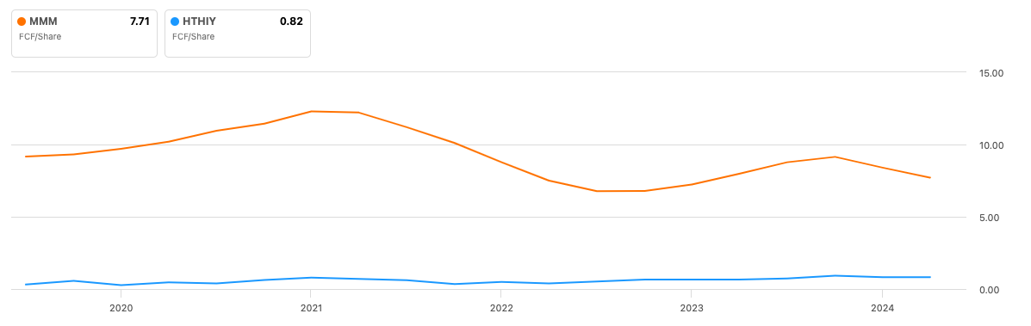

TRACKING FCF OVER TIME

Like many other financial metrics, free cash flow becomes more valuable when you track it over time. Instead of looking at a company’s FCF in isolation for a single period, it’s better to analyze how it changes year-over-year. This helps you identify trends that may signal deeper shifts in the company’s operations. Is FCF steadily increasing? That’s a sign the company is becoming more efficient. Is it declining? This could suggest problems with cash management or rising capital expenditures that aren’t paying off.

Also, remember that FCF can be cyclical depending on the industry. Companies in capital-intensive sectors like telecommunications or airlines may have more volatile FCF due to large, irregular capital expenditures.

For example, let's take a look at Air-France KLM's FCF/share level. The irregularity of its free cash flow is clearly demonstrated, with even negative territory in 2021 due to the Covid crisis.

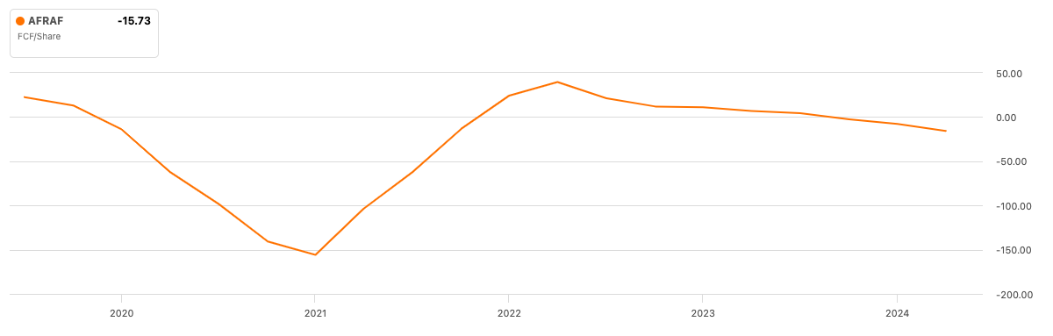

DIFFERENCES WITH NET INCOME OR REGULAR CASH FLOW

At this point, you might be wondering, “How is FCF different from net income or regular cash flow?” It all comes down to what’s included in the calculations.

Net income includes all sorts of non-cash items—things like depreciation, which reduces net income but doesn’t affect cash. It also includes revenue earned from sales that haven’t been paid for yet (sales on credit), which can make a company look more profitable than it really is in the short term. Meanwhile, regular cash flow (or cash from operations) focuses solely on how much cash is coming into the business. But it doesn’t account for capital expenditures, which are important for understanding how much cash a company has available after reinvesting in its operations.

Free cash flow solves both of these issues by focusing on the real cash available after all expenses, including capital expenditures, are accounted for. It gives you a more accurate picture of a company’s financial health.

THE EFFICIENCY METRIC

You’ve got the basics of FCF down, but there’s another important metric to consider: free cash flow margin. This ratio measures how much of a company’s revenue is converted into free cash flow. It’s a great way to gauge how efficiently a company is managing its operating costs and capital expenditures. It's important to put things in perspective!

To calculate FCF margin, divide FCF by total revenue and multiply by 100 to get a percentage:

$$Free cash flow margin=\left(\frac{Free cash flow}{Total revenue}\right)×100$$

The higher the FCF margin, the more efficient the company is at generating cash from its revenue. For instance, a company with a 20% FCF margin is converting 20% of every dollar of revenue into free cash flow. That’s a great sign of a well-run business!

If we get back to our previous example, with Hitachi and 3M (see graph below), we see that 3M does indeed seem to generate more cash than its competitor, compared to the revenue. At first glance, the company seems to be a safer choice, but perhaps the two companies have totally different cost structures!

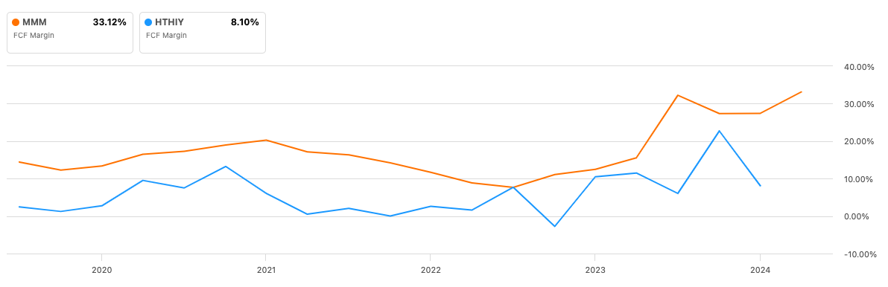

WHAT’S CONSIDERED A “GOOD” FCF?

So, what’s a good FCF? It depends on the industry. For example, in capital-intensive industries like manufacturing, a lower FCF might be acceptable because companies need to spend heavily on equipment and infrastructure. In contrast, a software company with minimal capex should have a much higher FCF relative to its revenue.

For SaaS (Software as a Service) companies, an FCF margin between 20% and 25% is generally considered healthy. Some investors use the Rule of 40 to evaluate SaaS companies—this rule suggests that the sum of a company’s growth rate and FCF margin should be at least 40. A higher number indicates strong financial health.

THE CHALLENGES

Despite its value, tracking FCF isn’t always straightforward. Companies don’t have to disclose FCF in their financial statements, meaning investors often have to calculate it themselves. Additionally, FCF can fluctuate depending on the timing of capital expenditures, so it’s important to evaluate it in context.

That said, keeping an eye on FCF is worth the effort. It can reveal key insights into how efficiently a company is using its cash and whether it’s likely to grow sustainably over the long term.

CONCLUSION



Free cash flow is a powerful tool in any investor’s arsenal. It provides a clear, no-nonsense view of how much cash a company has available after covering its expenses and reinvesting in itself. By focusing on FCF, you can gain a deeper understanding of a company’s financial health and make more informed investment decisions.

Remember: when you’re analyzing a company, don’t just get caught up in revenue growth or net income. Dig deeper, look at the FCF, and consider whether the company’s cash management is sustainable. After all, in the world of investing, it’s not just about how much money a company is making—it’s about how well it’s using that money to grow and create long-term value!

