KEY INVESTMENT INSIGHT #5
THE ANALYSIS OF REVENUE GROWTH



You’ve probably heard it said that revenue growth is the lifeblood of a business. And let's be honest, it's easy to get caught up in all the hype surrounding rapidly expanding companies. After all, who doesn’t love a good success story about a company that started small and then exploded onto the scene? But while it’s exciting to watch a company’s revenues soar, it’s also crucial to understand what’s really driving that growth and, more importantly, if it’s sustainable. Today, let’s dive into the revenue growth!

THE KEY TO IDENTIFYING TOMMOROW’S WINNERS?

When we talk about revenue growth, we're looking at the increase in a company’s sales from one period to the next. Simple, right? But here's the thing: Not all revenue growth is created equal. Some companies grow their top line by expanding into new markets, launching new products, or increasing prices. Others might benefit from favorable market conditions or even one-time events. The key is to discern which of these factors are at play and whether they can be sustained over time.

Imagine a tech startup that just launched a revolutionary new product. The initial sales might skyrocket, leading to impressive revenue growth. But what happens when the excitement dies down, and competitors catch up? If that company doesn’t have a plan to maintain its momentum, those growth numbers might plateau or even decline. Taking the example of WeWork (and two of its real estate development rivals, LuxUrban and DigitalBridge), which grew quite rapidly, the decline in revenue was just as dramatic:

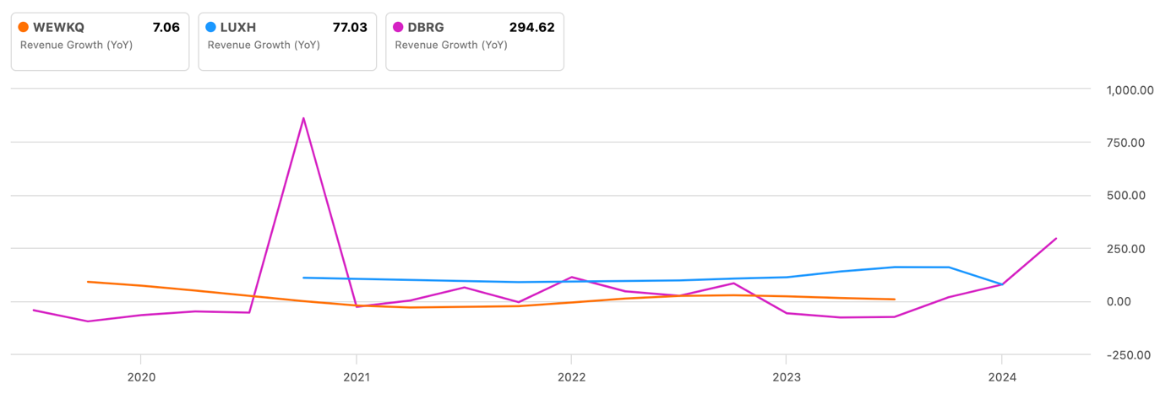

With very low growth rates that came close to 0 until the company went out of business, WeWork is suffering from poor management. When sales are growing, it's important to ask the right questions and not jump at the chance!

THE QUALITY OF GROWTH MATTERS

You might be wondering, “Isn’t any growth good growth?” Well, not exactly. High revenue growth can sometimes mask underlying problems. For instance, a company might be growing its revenues by slashing prices, but that can hurt profitability in the long run. Or, a firm could be acquiring new customers at a rapid pace, but if the cost of acquiring those customers is too high, it could erode the company’s margins.

Just take a closer look at how the growth is being achieved. Is the company adding value for its customers, or is it just relying on short-term tactics? Sustainable revenue growth often comes from a business’s ability to innovate, improve efficiency, and build strong customer relationships. When a company has a solid foundation, its growth is more likely to be consistent and reliable!

A CLOSER LOOK AT GROWTH DRIVERS

To really get to the bottom of a company’s revenue growth, you need to examine the drivers behind it. Here are a few key factors to consider:

- Market expansion: Is the company entering new geographic regions or demographics? Expansion into new markets can be a significant growth driver, but it also comes with risks, such as cultural differences and regulatory challenges.
- Product innovation: Companies that consistently innovate and introduce new products often enjoy sustained growth. However, innovation requires significant investment in R&D, and not every new product will be a hit.
- Pricing strategy: How is the company’s pricing evolving? A company might grow revenues by raising prices, but this could alienate customers if the price hikes aren’t justified by value.
- Customer acquisition and retention: A company’s ability to attract new customers and keep existing ones is crucial. High churn rates can be a red flag, indicating that the company is struggling to retain its customer base.

Understanding these drivers will give you a better sense of whether the company’s growth is likely to continue or if it’s at risk of tapering off.

THE RISK OF CHASING GROWTH

While it’s tempting to chase after companies with sky-high revenue growth, you have to be mindful of the risks involved. High growth often comes with increased volatility, and companies that are growing rapidly might be more vulnerable to market shocks. For example, a company that is rapidly expanding into new markets might face unforeseen challenges that could slow its growth. Additionally, companies that prioritize growth at all costs might stretch themselves too thin. They might take on too much debt, overestimate the market demand for their products, or expand too quickly, leading to operational inefficiencies.

So you should be cautious of companies that are growing too fast without a clear strategy for managing that growth. You have to look at the company’s balance sheet, cash flow, and profitability to ensure that the growth is sustainable and not just a short-term blip. As we often repeat in these newsletters, never base your investment choices on a single indicator!

FINDING THE RIGHT BALANCE

A common debate among investors is whether it’s better to invest in a company with high revenue growth or one that is more focused on profitability. The truth is, both are important, and the best companies often strike a balance between the two. As we said, a company that prioritizes revenue growth at the expense of profitability might eventually run into trouble. If a company isn’t generating enough profit to support its operations, it could face cash flow problems, which might lead to increased borrowing or, in the worst-case scenario, bankruptcy as for example WeWork.

On the other hand, a company that is too focused on profitability might miss out on growth opportunities. It’s essential for companies to invest in their future growth, whether that’s through R&D, marketing, or expanding into new markets.

The key for investors is to find companies that are growing their revenues while also maintaining healthy profit margins. These companies are often in a strong position to weather economic downturns and continue growing in the long run.

LEARNING FROM THE LEADERS

Let's talk about the importance of sustainable revenue growth by checking out two companies that have managed to grow impressively but with very different results.

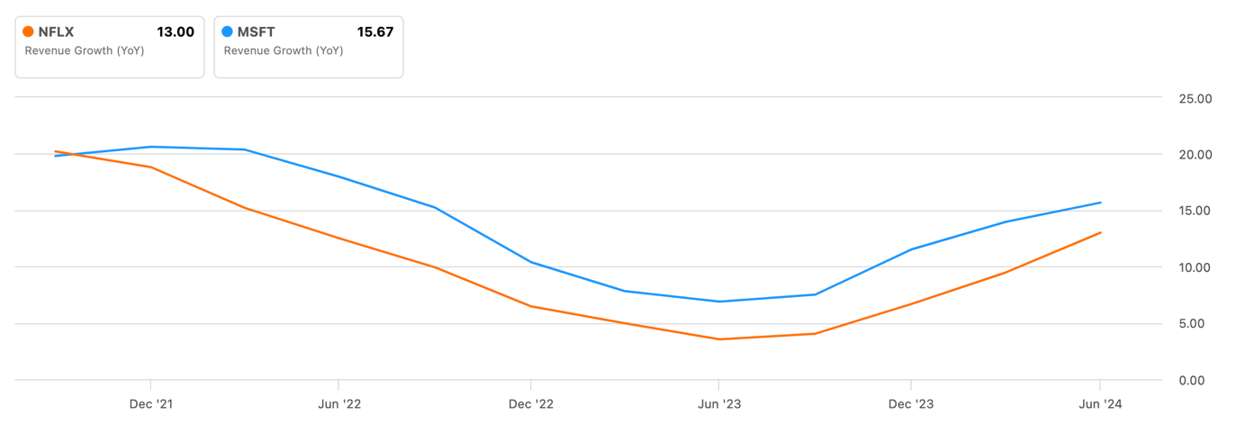

Netflix is a great example. As you can see from the chart, Netflix’s revenue growth took a bit of a dive until mid-2023, but then it started picking up again. They’ve been pouring money into creating original content and expanding internationally. This has helped them dominate the streaming market and keep those revenues flowing. But, let’s be real—this kind of aggressive expansion isn’t cheap. While they’ve grown fast, they’ve also had to deal with tighter profit margins because of the high costs involved.

On the flip side, Microsoft also saw its revenue growth slow down until the end of 2022 but then bounced back more quickly in 2023. Microsoft has been super smart about innovating and moving into new areas like cloud computing and AI. These moves have not only diversified their revenue streams but also helped them keep strong profit margins, thanks to their efficient operations and solid brand reputation. This balanced approach has kept Microsoft on a sustainable growth path, earning the trust of investors and keeping its stock price steady.

These examples show why it’s crucial to look beyond just the revenue numbers. Investors who focus only on top-line growth might miss the bigger picture and end up with companies that struggle to keep their success going long-term.

HOW TO IDENTIFY SUSTAINABLE REVENUE GROWTH



So, how can investors identify companies with sustainable revenue growth? Here are a few tips:

First and foremost, look for companies with strong competitive advantages: companies that have a unique product, a strong brand, or a loyal customer base are more likely to sustain their growth over time. These competitive advantages can create barriers to entry for competitors and allow the company to maintain its market position.

Examine the management team’s track record: a company’s leadership plays a crucial role in its ability to sustain growth. Look for management teams with a proven track record of successfully navigating challenges and driving growth. A strong management team can make all the difference in a company’s ability to execute its growth strategy.

Analyze the company’s financial health, through various indicators: a company’s financial statements can provide valuable insights into the sustainability of its growth. Look for companies with a strong balance sheet, positive cash flow, and healthy profit margins! These indicators can help you assess whether the company has the financial resources to support its growth.

Consider the industry’s growth potential: it’s easier for companies to grow when they operate in industries with strong tailwinds. Consider whether the company’s industry is expected to grow in the coming years, and whether the company is well-positioned to capitalize on that growth. This one’s not easy but practice makes perfect!

Evaluate the company’s investment in innovation: companies that invest in innovation are often better positioned to sustain their growth over the long term. Look for companies that are continuously improving their products and services and expanding their market opportunities, like Microsoft!

REVENUE GROWTH AS A TOOL, NOT A GOAL

Revenue growth is undoubtedly an important metric for investors, but it’s just one piece of the puzzle. By digging deeper into the drivers of growth and assessing the sustainability of that growth, investors can make more informed decisions and avoid the pitfalls of chasing short-term gains.

Remember, the best investments are often in companies that not only grow their revenues but do so in a way that is sustainable and profitable. So, the next time you’re analyzing a company’s financials, take a moment to look beyond the top line and consider the bigger picture. After all, in the world of investing, it’s not just about how fast you grow—it’s about how long you can keep it up!

